DRD4 polymorphism associated with greater positive affect in response to negative and neutral social stimuli.

Running title: DRD4 genotype and sustained positive affect in presence of negative social cues

T. LEE GILMAN*ª, MATTHEW T. FORDª, AARON M. JASNOW^{a,b}, KARIN G. COIFMANª

ªDepartment of Psychological Sciences & Brain Health Research Institute, Kent State University, Kent, OH, 44242

^{b}Department of Pharmacology, Physiology & Neuroscience, University of South Carolina School of Medicine, Columbia, SC, 29209

*Corresponding author
tgilman@kent.edu
144 Kent Hall
600 Hilltop Dr.
Department of Psychological Sciences
Kent State University
Kent, OH 44242

Affiliation Mailing Addresses:
ªDepartment of Psychological Sciences
144 Kent Hall
600 Hilltop Dr.
Kent State University
Kent, OH 44242

^{b}Pharmacology, Physiology & Neuroscience
Bldg 1 Room D-26
6439 Garners Ferry Road
School of Medicine Columbia
University of South Carolina
Columbia, SC 29209

Other author email addresses:
mford27@kent.edu
aaron.jasnow@uscmed.sc.edu
kcoifman@kent.edu

Annals of Human Genetics - Short Communication Requirements:

Running title max: 70 characters [68]

Summary max: 200 words [198]

Max words: 2000 [main body text: 2000]

Max references: 15 [15]

Max figures and tables: 4 [3]
Summary

Despite the robustness of DRD4 polymorphism associations with brain-based behavioral characteristics in candidate gene research, investigations have minimally explored associations between these polymorphisms and emotional responses. In particular, the prevalent single nucleotide polymorphism (SNP) -521C/T (rs1800955) in the promoter region of DRD4 remains unexplored relative to emotions. Here, two independent samples were evaluated using different emotion elicitation tasks involving social stimuli: Study 1 (N=120) evoked positive and negative emotional responses to validated film clips; Study 2 (N=122) utilized Cyberball to simulate social rejection and acceptance. Across Studies, C/C individuals self-reported higher mean positive affect scores using Likert scales versus T carrier individuals, selectively when presented with neutral or negative (but not positive) social stimuli. The consistent findings across these two Studies supports a functional consequence of this DRD4 SNP on emotion processing during changing social contexts. Continued investigation will help clarify if a C/C genotype enhances positive emotions under negative circumstances, or if the presence of the T allele reduces positive emotions, and how rs1800955 behavioral associations might generalize across different demographics. Future studies could also reveal if this SNP interacts with other changing environmental conditions to affect emotional responses, such as social limitations during the COVID-19 pandemic.

MeSH Keywords: affect; emotions; mental health; ostracism; polymorphism, single nucleotide; receptors, dopamine;
Introduction

Dopamine signaling in the brain contributes to a multitude of behavioral processes, including motor movement, learning processes, and emotional responses. Study of functional genetic polymorphisms in genes coding for dopamine receptors, particularly the G protein-coupled dopamine receptor D4 (DRD4), have demonstrated replicable polymorphism-behavior associations (Abrahams et al., 2019; Gizer et al., 2009; Thomson et al., 2013) and significant associations with brain activity as measured by functional MRI (Agam et al., 2014; Camara et al., 2010). Indeed, associations between DRD4 polymorphisms and behavior have been supported by literature reviews and meta-analyses (Gizer et al., 2009; Munafò et al., 2008). However, studies of other candidate gene polymorphisms have faced greater replicability challenges, leading to candidate gene studies as a whole to fall out of favor in the scientific realm (Border et al., 2019).

While much DRD4 polymorphism research has centered around impulsivity, addiction, and other externalized behaviors, some researchers have also explored how DRD4 polymorphisms relate to emotional responses. These have thus far exclusively focused on the DRD4 exon III variable number tandem repeat (VNTR). However, associations between another DRD4 polymorphism, the single nucleotide polymorphism (SNP) -521C/T (rs1800955) in the promoter region (Okuyama et al., 1999), and emotional responses have not been evaluated despite the role of emotions in externalizing behaviors and psychological health broadly defined. Nonetheless, both alleles of this SNP have been differentially associated with externalizing behavioral measures including smoking (C allele) (Pérez-Rubio et al., 2017), novelty seeking (T and C alleles, respectively) (Abrahams et al., 2019; Munafò et al., 2008), error processing (T allele) (Agam et al., 2014), and attention-deficit hyperactivity disorder (T allele) (Gizer et al., 2009). In particular, behaviors associated with reward and novelty seeking are heavily influenced by emotional responses, suggesting rs1800955 might also be associated with positive emotional responses (Abrahams et al., 2019; Camara et al., 2010; Pérez-Rubio et al., 2017). Here, we used two separate studies to assess how the DRD4 SNP -521C/T polymorphism was associated with positive emotional responses to positively and negatively valenced social stimuli. Positive emotions are an established factor in long-term psychological and physical health, and evolved to facilitate social connection and reward (Coifman et al., 2021; Fredrickson, 1998; Pressman et al., 2018). Given this polymorphism had not been previously evaluated with respect to emotion responses, we did not have any a priori hypotheses about how these genotypes might be associated with positive affective responses to negatively and positively valenced social stimuli.

Materials and Methods

Undergraduates of the Psychological Sciences department subject pool at a large midwestern public university in the United States were recruited as independent samples for Study 1 (N=120) or Study 2 (N=122). Study 1 was 79% of Western Eurasian ancestry, 62% female, 94% non-Hispanic/Latino, and Study 2 was 81% of Western Eurasian ancestry, 62% female, and 95% non-Hispanic/Latino. The present results are secondary data analyses of data collected between 2012-2015 for a parent project (Gilman et al., 2015) (see Supplementary Material), and for which sample sizes were determined based on power analyses, though Ns were limited in a few instances by practical considerations, such as the quality of extracted and amplified DNA. Full demographic data broken down into genotype categories is in Table 1. Written informed consent was obtained from all participants prior to each study, and all procedures were approved by the Kent State University Institutional Review Board and in accord with the Declaration of Helsinki.

Each participant provided 2 mL of passive drool saliva that was stored at −20°C until processing. As previously described (Gilman et al., 2015), genomic DNA was extracted (with prepIT-L2P from DNA Genotek, Inc., Ottawa, Canada), purified (with Genomic DNA Clean & Concentrator kit, Zymo Research, Irvine, CA), and diluted to a standard working concentration of 5 ng/μL. A modified touchdown PCR protocol was used (Gilman et al., 2015), with the reaction solution containing 0.5 μmol/L of forward (5′-CGG GGG CTG AGC ACC AGA GGC TGC T-3′) and reverse (5′-GCA TCG ACG CCA GCG CCA TCC TAC C-3′) primers (Integrated DNA Technologies, Inc., Coralville, IA) (Okuyama et al., 1999). Following completion of the PCR, a restriction fragment length polymorphism analysis was run on each sample by combining 10 μL of PCR product with 4 U/reaction of FspI in 1X CutSmart buffer (New England BioLabs, Ipswich, MA) for 1 h at 37°C. Undigested PCR products were run alongside digested PCR products in a 2% agarose gel. C allele products were not digested, and resulted in 285 bp amplimers, whereas T allele products were digested by FspI, splitting them into fragments that migrated at 176 and 109 bp.

Study 1 involved participants viewing a sequence of validated emotionally evocative film clips following a neutral baseline clip. In order, these were: 1) Big Cat Diary (baseline); 2) The Road to Guantanamo (negative); 3) Alive (positive); 4) The Champ (negative); 5) Between Two Ferns (positive); extensive details regarding these clips and their validation are published elsewhere (Gilman et al., 2017).

Study 2 involved participants engaging in a computer manipulation called Cyberball, validated to simulate social rejection and acceptance (Gilman et al., 2015). Briefly, this involved participants being told that they would play a video game with two other participants. In actuality, they were only playing with the computer program that, after a baseline (neutral) game involving equitable social participation, engages in a game that actively excludes the participant (rejection game), followed by a game that preferentially includes the participant (acceptance game).

After each film clip (Study 1) or Cyberball game (Study 2), participants were asked to self-report their emotional experiences with Likert scales ranging from 1-7 with positive (affection, amusement, enjoyment, happiness, interest, relief) emotion words. Word scores were aggregated into mean positive affective scores. Additional procedural details of Study 1 and Study 2 have been described extensively elsewhere (Gilman et al., 2015). Though negative emotion words were also self-reported and aggregated into mean negative affective scores, these were not the focus of our precise research question. Moreover, no significant genotype effects were observed for self-reported negative emotions (see Supplementary Material).

Relative to the preceding film clips in the sequence for Study 1, The Road to Guantanamo (t(119)=10.3, p<0.001) and The Champ (t(119)=5.59, p<0.001) significantly decreased positive affect as intended, and Alive (t(119)=−6.06, p<0.001) and Between Two Ferns (t(119)=−18.3, p<0.001) significantly increased positive affect. Similarly, the rejection game of Cyberball significantly reduced positive affect compared to the baseline game (t(121)=11.2, p<0.001), and the acceptance game significantly enhanced positive affect after the rejection game (t(122)=−5.20, p<0.001).

In line with previous investigations of rs1800955 (Munafò et al., 2008; Thomson et al., 2013), we compared individuals homozygous for the C allele (C/C) with those carrying at least one T allele (C/T and T/T individuals). Within each Study, data were analyzed using a repeated-measures ANOVA (genotype × film clip, Study 1; genotype × game, Study 2) and Bonferroni post-hoc analyses using IBM SPSS Statistics (v. 26.0.0.0, IBM Corp., Armonk, NY). Significance was set a priori at p<0.05, and mean positive affect scores were graphed as mean ± S.E.M. using GraphPad Prism (v. 9.3.1 (350), GraphPad Software, LLC., La Jolla, CA).

Results

Study 1 involved emotion elicitation through use of validated film clips (Gilman et al., 2015, 2017). Specifically, film clips alternating in negative and positive valences were presented. Mean positive affect after each film clip was quantified (Fig. 1), and a repeated measures ANOVA indicated a significant main effect of genotype for the DRD4 -521C/T SNP (F(1,118)=7.20, p=0.008, partial η²=0.06). Pairwise comparisons with Bonferroni post-hoc testing revealed that mean positive affect during the baseline “Big Cats” film clip (p=0.032) and the negatively valenced clip from “The Champ” involving social loss and sadness (p=0.009), were higher in individuals homozygous for the C allele as compared to T carriers. A similar non-significant trend (p=0.054) for C/C individuals exhibiting more positive affect than C/T and T/T individuals was noted for the other negatively valenced clip, “Road to Guantanamo”, that shows treatment of war prisoners. No significant differences between these two genotypes were detected for either of the positively valenced film clips, “Alive” (p=0.20) and “Between Two Ferns” (p=0.20).

Study 2 used a Cyberball task to simulate, following a neutral game round, peer rejection followed by peer acceptance (Gilman et al., 2015). Using this task, genotype for the DRD4 -521C/T SNP was significant for mean positive affect across the Cyberball task using a repeated measures ANOVA (F(1,120)=5.30, p=0.023, partial η²=0.04) (Fig. 2). Bonferroni post-hoc comparisons indicated that C/C individuals had higher mean positive affect during the baseline neutral game (p=0.024) and the social rejection game (p=0.009) relative to T carriers. No significant difference between these two genotypes was detected during the acceptance game (p=0.11). For Studies 1 and 2, main effects for genotype held even when mean negative affect was included as a covariate.

Discussion

Across two separate samples employing different emotional evocation tasks with social stimuli, C/C individuals consistently exhibited higher mean positive affect after baseline phases and following negatively valenced social manipulations than individuals with one or two T alleles. This work is the first to evaluate associations between the DRD4 -521C/T SNP and emotional responses to social stimuli. Further, the present findings are consistent with evidence that DRD4 polymorphisms are reliably associated with behavioral and neurophysiological shifts (Abrahams et al., 2019; Agam et al., 2014; Camara et al., 2010; Gizer et al., 2009; Munafò et al., 2008; Pérez-Rubio et al., 2017; Thomson et al., 2013), unlike other candidate genes that have encountered replication challenges (Border et al., 2019).

How the DRD4 -521C/T SNP affects DRD4 transcription and/or expression remains uncertain. One study observed in vitro that the T allele reduced transcriptional activity by approximately 40% (Okuyama et al., 2000), but this finding has not been replicated. Nonetheless, functional brain imaging studies (Agam et al., 2014; Camara et al., 2010) suggest this SNP impacts DRD4 translation or post-translational modifications that affect receptor function, an outcome that is not mutually exclusive of an absence in mRNA level differences. Our findings here provide support for a functional effect of this polymorphism on DRD4 receptors, and provide the first evidence of an impact of the rs1800955 polymorphism on emotion processing in the presence of positively and negatively valenced social stimuli.

Individuals homozygous for the C allele consistently exhibited higher mean positive affect at baseline and during negative emotion manipulations compared to T carriers. By nature of such genotype comparisons, it is presently not possible to determine if T carriers are generally more negative under such emotionally evocative circumstances, or if C/C individuals might be more positive during ambiguous or negative social experiences. Regardless, the consistent observation of a genotype-specific discrepancy across two different studies, restricted to portions of each task that are neutral or negatively valenced, suggests this is a reproducible effect likely to have real world consequences on emotional responses. Indeed, prior research has demonstrated the explicit role of positive emotion in healthy adaptation to stress (Coifman et al., 2021). Considering the uncertainty and myriad adverse outcomes resulting from the ongoing COVID-19 pandemic, it could be enlightening to evaluate if the DRD4 -521C/T SNP is associated with distinct perceptions regarding this global social stressor. Our Study samples limit the generalizability of these findings, given they consist of only of undergraduate students, and both Studies have majority Western Eurasian ancestry (see Supplementary Discussion), non-Hispanic/Latino, female participants. Thus, larger investigations powered for stratification of different social identities and educational access are warranted to verify our results.

Though candidate gene studies as a group have become limited in the literature in favor of genome wide sequencing studies (Border et al., 2019), select polymorphisms exhibiting replicable effects remain worth investigating. Examinations of genetic interactions with environmental manipulations, such as with the DRD4 -521C/T SNP and emotionally evocative social stimuli, facilitate identification of key molecular players in core behavioral responses known to drive health and psychological adaptation. Fundamental association studies like those presented here are necessary springboards for subsequent evaluations in pre-clinical rodent studies, as well as for more in-depth longitudinal assessments into how genetics shape neurophysiological processes and lifelong behavioral responses to changing environmental conditions.

Acknowledgements

The authors gratefully acknowledge Shaima Alhahmoud, Jessica J. Flynn, Lindsey Matt, and K. Maria Nylocks for their assistance in collecting saliva samples and running participants. The authors also acknowledge Maeson S. Latsko for her help with genotyping. This research was funded by the Institute for Clinical and Translational Research, Kent State University; and The Applied Psychology Center, Department of Psychological Sciences.

Author contributions
Study design: AMJ, KGC; Data collection: TLG, AMJ, KGC; Data analysis & visualization: TLG, MTF, KGC; Manuscript preparation: TLG; Manuscript revisions: TLG, MTF, AMJ, KGC; Funding acquisition: AMJ, KGC.

Conflict of interest statement: The authors have no conflicts of interest to declare.

Data availability statement: The data that support the findings of this study are available on request from the corresponding author. The data are not publicly available privacy and ethical restrictions, as stipulated by the Kent State University Institutional Review Board.

References

Abrahams, S., McFie, S., Lacerda, M., Patricios, J., Suter, J., September, A. V., & Posthumus, M. (2019). Unravelling the interaction between the DRD2 and DRD4 genes, personality traits and concussion risk. BMJ Open Sport — Exercise Medicine, 5(1), e000465. https://doi.org/10.1136/bmjsem-2018-000465
Agam, Y., Vangel, M., Roffman, J. L., Gallagher, P. J., Chaponis, J., Haddad, S., Goff, D. C., Greenberg, J. L., Wilhelm, S., Smoller, J. W., & Manoach, D. S. (2014). Dissociable Genetic Contributions to Error Processing: A Multimodal Neuroimaging Study. PLoS ONE, 9(7), e101784. https://doi.org/10.1371/journal.pone.0101784
Border, R., Johnson, E. C., Evans, L. M., Smolen, A., Berley, N., Sullivan, P. F., & Keller, M. C. (2019). No Support for Historical Candidate Gene or Candidate Gene-by-Interaction Hypotheses for Major Depression Across Multiple Large Samples. American Journal of Psychiatry, 176(5), 376–387. https://doi.org/10.1176/appi.ajp.2018.18070881
Camara, E., Krämer, U. M., Cunillera, T., Marco-Pallarés, J., Cucurell, D., Nager, W., Mestres-Missé, A., Bauer, P., Schüle, R., Schöls, L., Tempelmann, C., Rodriguez-Fornells, A., & Münte, T. F. (2010). The Effects of COMT (Val108/158Met) and DRD4 (SNP −521) Dopamine Genotypes on Brain Activations Related to Valence and Magnitude of Rewards. Cerebral Cortex, 20(8), 1985–1996. https://doi.org/10.1093/cercor/bhp263
Coifman, K. G., Seah, T. H. S., Nylocks, K. M., Wise, A., Almahmoud, S., Summers, C., Aurora, P., Garcia, M., & Delahanty, D. L. (2021). Micro Versus Macro Processes: How specific stress exposure impacts sleep, affect, and risk-related behavior on the path to disease in high-risk adults. Anxiety, Stress, & Coping, 34(4), 381–396. https://doi.org/10.1080/10615806.2021.1888933
Fredrickson, B. L. (1998). What Good Are Positive Emotions? Review of General Psychology, 2(3), 300–319. https://doi.org/10.1037/1089-2680.2.3.300
Gilman, T. L., Latsko, M., Matt, L., Flynn, J., Cabrera, O. de la C., Douglas, D., Jasnow, A. M., & Coifman, K. G. (2015). Variation of 5-HTTLPR and Deficits in Emotion Regulation: A Pathway to Risk? Psychology & Neuroscience, 8(3), 397–413. https://doi.org/10.1037/pne0000017
Gilman, T. L., Shaheen, R., Nylocks, K. M., Halachoff, D., Chapman, J., Flynn, J. J., Matt, L. M., & Coifman, K. G. (2017). A film set for the elicitation of emotion in research: A comprehensive catalog derived from four decades of investigation. Behavior Research Methods, 49(6), 2061–2082. https://doi.org/10.3758/s13428-016-0842-x
Gizer, I. R., Ficks, C., & Waldman, I. D. (2009). Candidate gene studies of ADHD: a meta-analytic review. Human Genetics, 126(1), 51–90. https://doi.org/10.1007/s00439-009-0694-x
Munafò, M. R., Yalcin, B., Willis-Owen, S. A., & Flint, J. (2008). Association of the Dopamine D4 Receptor (DRD4) Gene and Approach-Related Personality Traits: Meta-Analysis and New Data. Biological Psychiatry, 63(2), 197–206. https://doi.org/10.1016/j.biopsych.2007.04.006
Okuyama, Y., Ishiguro, H., Nankai, M., Shibuya, H., Watanabe, A., & Arinami, T. (2000). Identification of a polymorphism in the promoter region of DRD4 associated with the human novelty seeking personality trait. Molecular Psychiatry, 5(1), 64–69.
Okuyama, Y., Ishiguro, H., Toru, M., & Arinami, T. (1999). A Genetic Polymorphism in the Promoter Region of DRD4 Associated with Expression and Schizophrenia. Biochemical and Biophysical Research Communications, 258(2), 292–295. https://doi.org/10.1006/bbrc.1999.0630
Pérez-Rubio, G., Ramírez-Venegas, A., Díaz, V. N., Gómez, L. G., Fabián, K. E., Carmona, S. G., López-Flores, L. A., Ambrocio-Ortiz, E., Romero, R. C., Alcantar-Ayala, N., Sansores, R. H., & Falfán-Valencia, R. (2017). Polymorphisms in HTR2A and DRD4 Predispose to Smoking and Smoking Quantity. PLoS ONE, 12(1), e0170019. https://doi.org/10.1371/journal.pone.0170019
Pressman, S. D., Jenkins, B. N., & Moskowitz, J. T. (2018). Positive Affect and Health: What Do We Know and Where Next Should We Go? Annual Review of Psychology, 70(1), 1–24. https://doi.org/10.1146/annurev-psych-010418-102955
Thomson, C. J., Hanna, C. W., Carlson, S. R., & Rupert, J. L. (2013). The −521 C/T variant in the dopamine‐4‐receptor gene (DRD4) is associated with skiing and snowboarding behavior. Scandinavian Journal of Medicine & Science in Sports, 23(2), e108–e113. https://doi.org/10.1111/sms.12031
Tables

Table 1. Demographics for Studies 1 and 2.

 |  |  | C/C | C/T or T/T
Study 1 Demographics |  |  | N=28 | N=92
 | Age |  | 20.39 (5.08) | 20.98 (6.78) | t(118)=−0.42, p=0.67
 | Gender |  | 16 Female  12 Male | 58 Female  34 Male | χ²=0.32, p=0.57
 | Biogeographic Ancestry |  |  |  | χ²=4.36, p=0.23
 |  | Western Eurasian | 23 | 72
 |  | Sub-Saharan | 2 | 12
 |  | East or Southern Asian | 2 | 1
 |  | Other | 1 | 7
 | Ethnicity |  | 1 Hispanic/Latino | 6 Hispanic/Latino | χ²=0.34, p=0.56
 |  |  | C/C | C/T or T/T
Study 2 Demographics |  |  | N=35 | N=87
 | Age |  | 19.45 (2.38) | 20.67 (5.00) | t(120)=−1.38, p=0.17
 | Gender |  | 20 Female  15 Male | 56 Female  31 Male | χ²=0.56, p=0.46
 | Biogeographic Ancestry |  |  |  | χ²=7.40, p=0.06
 |  | Western Eurasian | 32 | 67
 |  | Sub-Saharan | 0 | 11
 |  | East or Southern Asian | 1 | 3
 |  | Other | 1 | 0
 | Ethnicity |  | 2 Hispanic/Latino | 4 Hispanic/Latino | χ²=0.05, p=0.82

Figure Legends

Figure 1. Mean self-reported positive affect scores in response to film clips in Study 1. Film clips were shown to participants in the following sequence: 1) “Big Cats” (Baseline); 2) “The Road to Guantanamo (Gitmo); 3) Alive; 4) The Champ (Champ); 5) Between Two Ferns (Ferns). Purple circles (refer to online version for color) with solid lines indicate individuals with C/C genotypes (N=28); black circles with dotted lines indicate individuals with at least one T allele (N=92). Data are graphed as mean ± S.E.M. *p=0.032; **p=0.009 comparing C/C with C/T or T/T for that specific film clip. Scores between genotypes for the Gitmo film clip approached significance (p=0.054, vertical line).

Figure 2. Mean self-reported positive affect scores in response to Cyberball games in Study 2. Participants engaged in a Cyberball task that involved three consecutive games: 1) a baseline game (Neutral); 2) a game designed to simulate social rejection (Reject); 3) a game designed to simulate social acceptance (Accept). Purple circles (refer to online version for color) with solid lines indicate individuals with C/C genotypes (N=35); black circles with dotted lines indicate individuals with at least one T allele (N=87). Data are graphed as mean ± S.E.M. *p=0.024; **p=0.009 comparing C/C with C/T or T/T for that specific game.
Figures

Figure 1

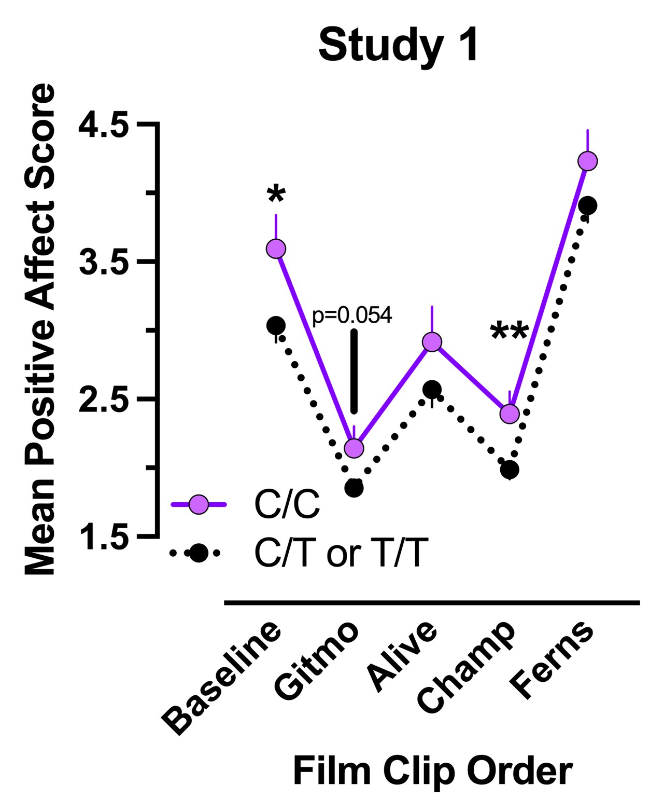

Figure 2

